

|  |
| --- |
| Photo displaying partial image of two pie charts on a canvas-textured page |
| Project Report Template  **LECTURER’S NAME: DR. ZAHEERA BINTI ZAINAL ABIDIN** |
| |  |  |  | | --- | --- | --- | | Group Name: | [Date] | BITS 3363 Network Security Project Management | |

FACULTY OF INFORMATION AND COMMUNICATION TECHNOLOGY

SEMESTER 1-2021-2022

**PREPARED BY: (GROUP NAME)**

1. **XXX Student name**
2. **XXX**
3. **XXX**
4. **XXX**
5. **XXX**
6. **XXX**

**TABLE OF CONTENT**

|  |  |  |
| --- | --- | --- |
| **CONTENT** | | **PAGE NO** |
| 1.0. | COMPANY PROFILE [what to write in company profile ??? your team company background and culture/nature of the business, Organizational Planning – Role, Organization Chart, who is your company’s clients, then describe the solution for your client] and Stakeholder Analysis | X |
| 2.0. | SCOPE | X |
|  | Project Charter | X |
|  | Scope Planning - Statement Plan Details and Scope Management Plan | X |
|  | Scope Definition – Work Breakdown Structure | X |
| 3.0. | TIME – Activity Definition, Sequence, Duration, Development  Gantt Chart, Milestone, PERT | X |
| 4.0. | COST – Resource Planning and Cost estimating | X |
| 5.0. | QUALITY – Quality Cost Planning, Operational Budget | X |
| 6.0 | NETWORK SECURITY AUDIT AND RISK ASSESSMENT | X |
|  | Identification – Asset, Threat and Vulnerability | X |
|  | Risk Mitigation Planning - for each identification | X |
| 7.0 | PROPOSED SOLUTION | X |
|  | Planning and designing the proposed solution | X |
|  | Lesson Learned | X |

1. **COMPANY PROFILE**

Background and culture/nature of the business

* **Your company (e.g. Co XYZ) provides services of protecting data in the network and system development for your client. Choose your** **preferred client** **based on agreement from your group members.**
* **Brief about your company – inform who is the CEO and stakeholders for your company and so forth, organizational planning (show your organization chart, mission, goal and services provided to customer/client)**
* **SWOT Analysis**
* **Organizational Chart for Network Attack and Penetration Project**
* **State your current client and solution for problem in current client to be solved (just 2/3 sentences to describe problem in general).**

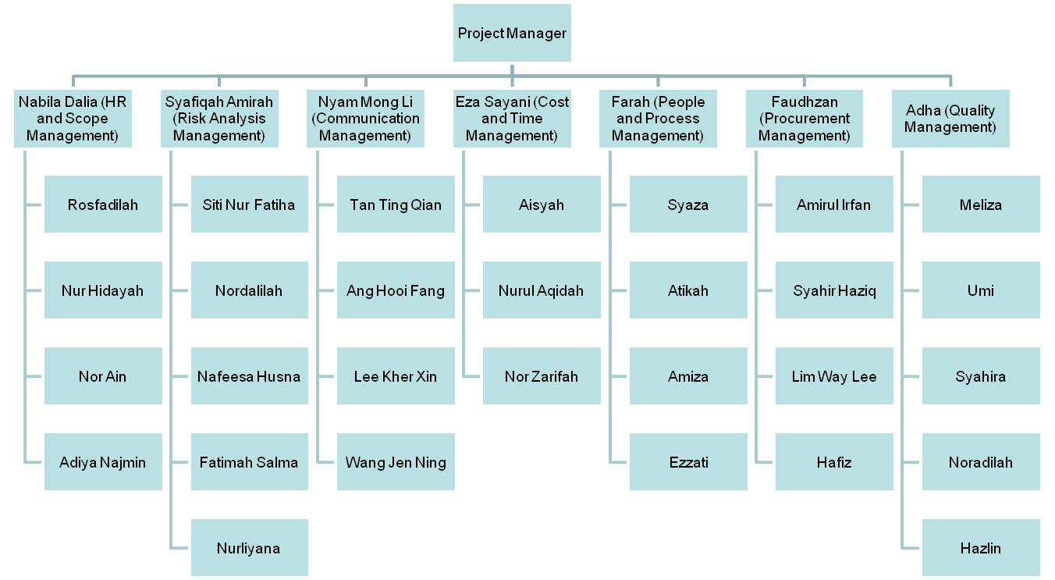

**Sample**

**Figure 1:**  This is a functional structure of organization (sample)…based on your project it could be matrix or project structure.

**Meeting 1– written progress report (Sample)**

**Date:**

**Meeting Objective:**

* Introductions of attendees
* Background of project
* Review of project-related documents (i.e. business case, project request, contract)
* Discussion of project organizational structure
* Discussion of project scope, time, and cost goals
* Discussion of other important topics
* List of action items from meeting

|  |  |  |
| --- | --- | --- |
| Action Item | Assigned To | Due Date |
| Work Breakdown Structure | HR and Scope Management | *dates* |
| Organizational Chart | HR and Scope Management |  |
| Gantt Chart | Project, Process and People Management |  |
| Risk Analysis Layout | Risk Analysis Management |  |
| Defining stakeholders | Project, People and Process Management |  |
| Commence quality planning, assurance and control | Quality Management |  |
| Budget Estimation | Cost and Time Management |  |
| Provide Make-or-Buy Analysis and Appropriate Sellers | Procurement Management |  |
| Provide training and bonding with other organization | Communication Management |  |

Date and time of next meeting: 03/09/2019

**Roles and Responsibilities**

|  |  |  |  |
| --- | --- | --- | --- |
| **Role** | **Name** | **Organization/**  **Position** | **Contact Information** |
| HR Manager | *Name* | HR Leader | *Email / HP* |
| Procurement Manager |  | Procurement Leader |  |
| Quality Manager |  | Quality Leader |  |
| Risk Analysis Manager |  | Risk Analysis Leader |  |
| Cost Manager |  | Cost Leader |  |
| Process and People Manager |  | Process and People Leader |  |
| Communication Manager |  | Communication Leader |  |

**Sign-off:** (Signatures of all above stakeholders. Can sign by their names in table above.)

**Comments:** (Handwritten or typed comments from above stakeholders, if applicable)

**Team Contract**

**Project Team Members Names and Sign-off:**

|  |  |
| --- | --- |
| **Name** | **Sign-off on Team Contract** |
| *Name* | *Signature* |
|  |  |
|  |  |
|  |  |
|  |  |
|  |  |

**Code of Conduct:** As one of the project member, I will:

* Work as a team and finish up the project until the end of the project.
* Research and help each other in developing this project.
* Commit to our work and abide to all the rules being set by this organization.

**Participation:**

* Give full effort and energy so that project runs smoothly.
* Ask for help if does not know how to complete a task.
* Report any circumstances to the leader.

**Communication:**

* Communicate effectively with each other to meet the project’s need.
* Brainstorm and set up meetings to update each work that has been done.
* Meet up not only at workplace but also during free time.

**Problem Solving:**

* Analyze and provide solution if necessary.
* Link and bonding with other organization to tackle problem.

**2.0 SCOPE**

Project Charter

Date

|  |  |  |  |
| --- | --- | --- | --- |
| **Project Title**: | | | |
| **Project Start Date: Projected Finish Date:** | | | |
| **Budget Information:**  **N/A** | | | |
| **Project Manager:**  **Sample** | | | |
| **Project Objectives:**  - | | | |
| **Success Criteria:**  **-** | | | |
| **Approach:** | | | |
| **Roles and Responsibilities** | | | |
| ***Name and Signature*** | ***Role*** | ***Position*** | ***Contact Information*** |
|  |  |  |  |
|  |  |  |  |
|  |  |  |  |
|  | | | |
| **Comments:** (Handwritten or typed comments from above stakeholders, if applicable) | | | |

**Project Charter - Sample**

**Project Title**: High network attack and penetration

**Project Start Date: x**x/xx/xxxx

**Project Finish Date: xx**/xx/xxxx

**Budget Information:** RM 2 million

**Project Manager:**

**Project Objectives:**

To provide solutions towards threat and risk involved in high network attack and penetration. This project is done to help our organization to issue prevention mechanism for our organization that can be used for later generation when the same problems occurred. It is also to discuss and layout the vulnerabilities exploited from network environment towards our organization. This project involves cost, time, quality, procurement, human resource, communication, processes and people management. It is also to develop soft skills and technical skills between team members besides learning to finish up project in time.

**Approach:**

1. Consult project manager and make discussion, meetings and brainstorming with every members involved.
2. Search and relate project to past projects and research to give an overview about managing projects.
3. Issue an interview, refer business occasions and relate workshop 2 during project commencement.

**Scope Planning**

Scope Statement

|  |
| --- |
| **Project Title:**  **Date:**  **Prepared by:** |
| **Project Justification:** |
| **Product Characteristics and Requirements:** |
| **Product User Acceptance Criteria:**  **Summary of Project Deliverables**  **Project management-related deliverables:**  **Product-related deliverables:** |

**Scope Definition**

[Explain the nature of the business – understand your client’s needs by looking at the nature of the business. If your client is from the fashion domain, then you need to know from A to Z about the latest fashion, materials for normal attire or formal event. ]

**Choose your clients from various domain:**

* Domain: Oil and Gas – Client: example ExxonMobil or Petron
* Domain: Transportation – Client: example PLUS (Highway) or MRT (Train)
* Domain: Restaurant – Client: example McD or KFC
* Domain: Food manufacturing – Client: example Gardenia or Ali Cafe
* Domain: Fashion – Client: example Online boutique
* Domain: Logistics – Client: example Panda or Grab

**Weighted Scoring Method**

Projects are listed based on the requirements and weighted for decision making. The criteria of the product or services that will be implemented is listed in Table 1.

**Weighted Scoring Method (WBS)**

**[put WBS done in open workbench or project libre here]**

**STAKEHOLDER ANALYSIS**

* **Stakeholder Analysis for Network Security Infrastructure (Sample)**

**Prepared by:** xxxxx **Date: xx/xx/xxxx**

|  |  |  |  |  |  |  |
| --- | --- | --- | --- | --- | --- | --- |
| **Name** | **Organization** | **Role on project** | **Unique facts about stakeholder** | **Level of interest** | **Level of influence** | **Suggestions on managing relationships** |
| Kenny Roger | XYZ Enterprise | Project Sponsor | Generous | High | High | Always present ideas confidently to convince the project sponsor from supporting the project. |
| Abu | FTMKBitz Bhd | Network Manager | Responsible | High | High | Report the status of progress project on time to project sponsor and conduct small meeting when necessary. |
| Ashley Chua  Cherry Lim  Cheryl Pua  John Ng | FTMKBitz Bhd | Project Team Members | Careless  Caring  Cheerful  Punctual | High | High | Always help each other in the process of completing the project. |
| Alice Yong | Junichi Trading | Customer | Patience | High | High | Explain the project nicely and clear customers’ doubts with clear explanation. |

**3.0 TIME**

**Explain about the activity, duration and sequence from one activity to another activity.**

**Explain about dependency, estimated time for the activity (show PERT Diagram) and show the milestone at Gantt chart).**

**Show your Gantt Chart (paste here)**

**CPM (paste here)**

**4.0 COST**

**Explain about your planning to spend on resource, manpower, hardware and software purchase. Identify from your equipment and resources that which is tangible, intangible, direct and indirect cost involved.**

**How much you want to reserve for contingency planning.**

**Show your cost done at Workbench**

**5.0 QUALITY**

**Explain how you going to improve the quality of your services to your client.**

**Technique to use for improving the service provided. (such as flow chart, pareto and testing planning – how are you going to test your secured network?)**

**Fishbone Diagram**

**Explain standard used for project such as ISO.**

**6.0 NETWORK SECURITY AUDIT AND ASSESSMENT**

**List the asset, threat, vulnerability in the project as in Table 1. (you have done it at Assignment 1, so just paste it here)**

**Table 1**: Identification (Assets, Threats, Risks and Mitigation Planning)

**Example Client: University**

|  |  |  |  |  |  |  |
| --- | --- | --- | --- | --- | --- | --- |
| 3 pillars of cyber security | Assets | Assets  Description | Vulnerability | Threats | Risks | Risk Mitigation |
| People | * Talent | * Employee * Contract Worker | * Learning Curve * Health Condition | * Absenteeism * Careless | * Low in productivity * Low in Work Quality | * Job Posting * Training |
| Process | * Policy | * Password & Username | * Easily guess | * Forgetful * Ignorance | * Dictionary Attack | * Awareness Program |
| Technology | * Hardware | * Router | * Software Patches | * No Electricity | * Re-direction of path | * Hardware Redundancy |
| * Software | * Student   Management  System | * Data Reliability | * Malware Attack | * System Down | * Proxy |

**Sample**

* Employee – Absenteeism
* Password
* Router
* Student Management System (SMP)

**“Discover”**

**Data gathering**

**“Analyze”**

**Data Analysis**

**“Fix”**

**Safeguards**

* Attendance Sheet / Face Recognition
* Careless
* Password format
* Packet Types, No. of hops and Interface
* Data Reliability
* Physical Security /

Access Control

* Professional Certification
* Password Policy/Standard
* Change the routing protocol / change the name of interface
* Improve Network Bandwitdh

Figure 2: Iterative Assessment Map – Example of University as a Client

(paste from Assignment1)

# **7.0 PROPOSED SOLUTION**

**Planning and Designing the Logical and Physical Topologies**

In the planning and designing process, the project team produces the logical topology and physical topology of the network security architecture. The project manager needs to manage the IP address as shown in Figure x, design the security services, cabling, wireless set up, security in servers, UPS, RAID and air conditioner in data centers and riser room. Figure x shows example of logical and physical topology or also called as network architecture.

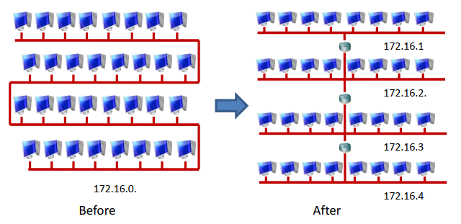

**Sample**

Figure x: Example of IP Addressing Planning

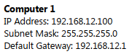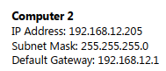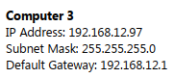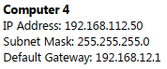

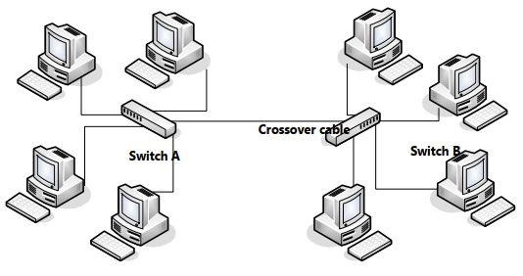

Figure x: Example of Logical and Physical Topology or Network Architecture

**Lessons Learned Report (Sample)**

|  |
| --- |
| **Prepared by:** HR Management **Date:** 30/12/2020  **Project Name:** High Network Attack and Penetration (Example)  **Project Sponsor:** xxxxx  **Project Manager:** xxxx  **Project Dates:** 01/09/2020 – 30/12/2020  **Final Budget:** RM 20 million |
| 1. Did the project meet scope, time, and cost goals? 2. What was the success criteria listed in the project scope statement? 3. Reflect on whether or not you met the project success criteria. 4. In terms of managing the project, what were the main lessons your team learned?   5. Describe one example of what went right on this project.  6. Describe one example of what went wrong on this project.  7. What will you do differently on the next project based on your experience  working on this project? |